AUTONOMOUS BATTLE DAMAGE ASSESSMENT

REQUIREMENTS
(v1.0-FINAL)

DOCUMENT HISTORY

DATE | STATUS | VER | AUTHOR | NOTES
20260121 | Draft | 0.1 | Nicholas Lind | Create initial draft
20260122 | Draft | 0.2 | Carlos Gil | Added users, new requirements
20260124 | Draft | 0.3 | Nicholas Lind | Added event flow
20260127 | Draft | 0.4 | Nicholas Lind | Performance, usability, maintainability
20260205 | Draft | 0.5 | Carlos Gil | Restructured requirements
20260207 | Draft | 0.6 | Carlos Gil | Added references
20260208 | Final | 1.0 | Carlos Gil | Expanded scope section
1.0 INTRODUCTION

A Battle Damage Assessment (BDA) “provides the timely and accurate estimate of damage resulting from the application of lethal and nonlethal military force” [1]. Currently, a BDA requires prolonged physical target inspection and/or manual image analysis, the latter of which becomes increasingly cumbersome in direct proportion to the volume of data collected. To address these challenges, our project aims to (1) objectively evaluate VLM-generated BDAs using open-source data and (2) develop an autonomous, self-contained software service that can create VLM-generated BDAs onboard edge devices.

To define the project’s characteristics, this document specifies the intended users, key terminology, system functionality and scope. It also delineates the project’s requirements as well as resources needed to develop and operate the service effectively.

2.0 INTENDED USERS

There are three primary groups expected to use the automated BDA service:

- AI2C Project Team - The project team requires an automated BDA service to evaluate the ability of VLMs to generate BDAs. To achieve this goal, team members will provide all the open-source images, prompts, assessment templates and reference BDAs.

- Army Research Lab (ARL) - The ARL requires an objective evaluation system to determine VLM accuracy and performance within the realm of damage assessment. The evaluation system will help foster future experimentation at ARL and within the larger research community.

- ARL Autonomous Systems - Edge devices require an onboard BDA service to autonomously generate BDAs against select objects of interest. The onboard BDA system will integrate with device sensors (i.e. camera) to generate the locally-stored BDAs (for later retrieval).

3.0 KEY TERMINOLOGY

Console: a text-based program that allows a user to interface with the underlying system.

JavaScript Object Notation (JSON): a human-readable, structured data interchange format.

Video RAM (VRAM): dedicated, high-speed memory that resides on a graphics card (GPU).

Vision-Language Model (VLM): a multimodal, generative AI model that is capable of understanding and processing data in disparate formats, whether image, video or text.
4.0 FUNCTIONAL REQUIREMENTS

4.1 The BDA service will provide the following:

4.1.1 User interface:

FRID | USER INTERFACE REQUIREMENT
FR.U1 | System provides a command-line interface compatible with any Linux environment
FR.U2 | System provides a help menu and usage guidance via a standard “-h” argument
FR.U3 | System allows user to change model and prompt via a YAML configuration file
FR.U4 | System prints errors and status updates to the console

4.1.2 Processing:

FRID | PROCESSING REQUIREMENT
FR.P1 | System accesses input source (single or multiple)
FR.P2 | System determines the presence of valid objects within input imagery
FR.P3 | System detects input that is unsuitable due to quality issues or extraction errors
FR.P4 | System does not terminate (if additional imagery remains) after an input error

4.1.3 Analysis:

FRID | ANALYSIS REQUIREMENT
FR.A1 | System uses the appropriate BDA template and model prompt for the VLM phase
FR.A2 | System uses VLM to assess physical and functional damage inflicted on object
FR.A3 | System embeds datetime, model name, input source and confidence within BDA

4.1.4 Report:

FRID | REPORT REQUIREMENT
FR.R1 | System writes BDA analysis in JSON format to a text file that is stored locally
FR.R2 | System stores BDAs in appropriate folder, either user-selected or in default location
FR.R3 | System adds image name and UTC timestamp to each report filename
FR.R4 | System logs a summary of processed images to the console

4.2 The following comprises the flow of events:

4.2.1 Primary Flow: The user executes the program and selects source/destination locations. The system validates and processes inputs and then exports the BDA as a local JSON file.

4.2.2 Alternative Flow A (Invalid or Corrupt): The system detects invalid input data, notifies the user and (if applicable) continues processing the next input in the sequence.

4.2.3 Alternative Flow B (Low Confidence Assessment): The system produces an assessment with low confidence, notifies the user and marks confidence level within the generated file.

4.3 The context diagram displaying interactions between the system and its intended users may be found under Appendix A. Both development and production branches are represented.

5.0 NON-FUNCTIONAL REQUIREMENTS

5.1 The BDA service operates in accordance with the following:

5.1.1 Usability:

NRID | USABILITY REQUIREMENT
NR.U1 | System is executable system-wide by standard (non-root) users
 | FRID: FR.U1, FR.U2, FR.U3, FR.U4, FR.R1, FR.R2, FR.R4
NR.U2 | System is simple to use for users following system guidance
 | FRID: FR.U2, FR.U4, FR.R4
NR.U3 | System requires read access to the input source
 | FRID: FR.P1
NR.U4 | System operates without external dependencies or network connectivity
 | FRID: FR.A1, FR.A2
NR.U5 | System regularly logs status updates and specific error messages to the console
 | FRID: FR.U4, FR.P1, FR.P2, FR.P3, FR.P4, FR.R4
NR.U6 | System uses default input and output folders (if none provided by user)
 | FRID: FR.P1, FR.R2
NR.U7 | System does not overwrite or delete prior generated assessments
 | FRID: FR.R1, FR.R3

5.1.2 Performance:

NRID | PERFORMANCE REQUIREMENT
NR.P1 | System does not occupy more than 20 GB of hard drive space
 | FRID: FR.U1, FR.R1
NR.P2 | System does not use more than 16 GB VRAM (for model processing)
 | FRID: FR.P2, FR.A2
NR.P3 | System determines the presence of one valid object in under three seconds
 | FRID: FR.P2
NR.P4 | System performs analysis of single image in under 15 seconds
 | FRID: FR.A1, FR.A2

5.1.3 Accuracy:

NRID | ACCURACY REQUIREMENT
NR.A1 | System uses BDA templates that are consistent with U.S. military doctrine
 | FRID: FR.A1
NR.A2 | System correctly assesses damage levels using appropriate BDA template
 | FRID: FR.A1, FR.A2
NR.A3 | System requires write access to the specified or default output folder
 | FRID: FR.R1, FR.R2
NR.A4 | System generates standards-based [2] (syntactically correct) JSON files
 | FRID: FR.R1

5.1.4 Maintainability:

NRID | MAINTAINABILITY REQUIREMENT
NR.M1 | System implements a container-based modular design
 | FRID: FR.U1, FR.U3
NR.M2 | System is easily upgradeable by replacing independent modules
 | FRID: FR.U1, FR.U3
NR.M3 | System implemented by a centralized version control system
 | FRID: FR.U1

6.0 PROJECT SCOPE

REQUIREMENT | SCOPE / COVERAGE | PRIORITY
User Interface | Linux CLI with help text and editable configuration file. The program is non-interactive past the initial prompt. | Medium
Processing | Local JPG or PNG images of non-moving target(s). Images are processed sequentially. | High
Analysis | Reports contain only BDA phase 1 and partial phase 2 elements. Reports generated by a single model. | Critical
Report | JSON file stored on local filesystem. File validated against predefined schema. | Medium

7.0 RESOURCE REQUIREMENTS

- Data: Open-source, labeled dataset used for training, testing and validation

- Hardware: Local development computer featuring GPU with 16 GB VRAM.

- Cloud Infrastructure: Google Drive will store dataset and Docker Hub will hold Docker images. Software will be version controlled through GitHub and developed/tested through a CI/CD pipeline facilitated by GitHub Actions. All code changes will undergo automated testing prior to being merged from the relevant development branch.

- Non-Development Human Effort: Project team will gather and process all open-source data.
8.0 REFERENCES
[1] Chairman of the Joint Chiefs of Staff, Methodology for Combat Assessment, CJCSI 3162.02A, Washington, DC: Joint Staff, July 16, 2021.
[2] T. Bray, “RFC 8259: The JavaScript Object Notation (JSON) data interchange format,” IETF Datatracker, https://datatracker.ietf.org/doc/html/rfc8259 (accessed Jan. 30, 2026).
[3] Sruthy, “Functional and Non Functional Requirements (updated 2026),” Software Testing Help, https://www.softwaretestinghelp.com/functional-and-non-functional-requirements/ (accessed Jan. 21, 2026).
[4] Curtis, “Understanding Flow of Events in Use Cases,” Go UML, https://www.go-uml.com/understanding-flow-of-events-in-use-cases-a-step-by-step-guide (accessed Jan. 21, 2026).

9.0 REFLECTION
This document was challenging to write until the project team members, with input from ARL mentors, established a suitable scope and decided on the nature of our deliverables. Without a clear aim, requirements could not be specified. The project team made this process more efficient by meeting regularly with mentors and by holding daily meetings. Also, given the wide array of experience and skillsets within the team, a software prototype was rapidly developed. This in turn helped the team understand the nature of the scope.
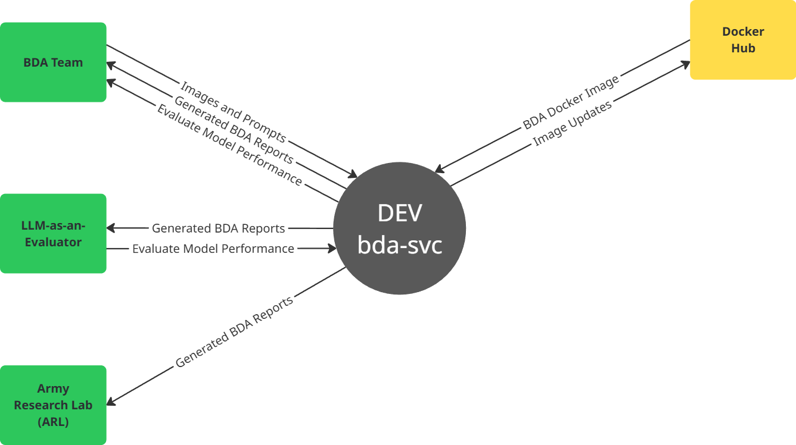
10.0 APPENDIX A

BDA Service
Key Goals
Stretch Goals

Figure A1, Development Environment
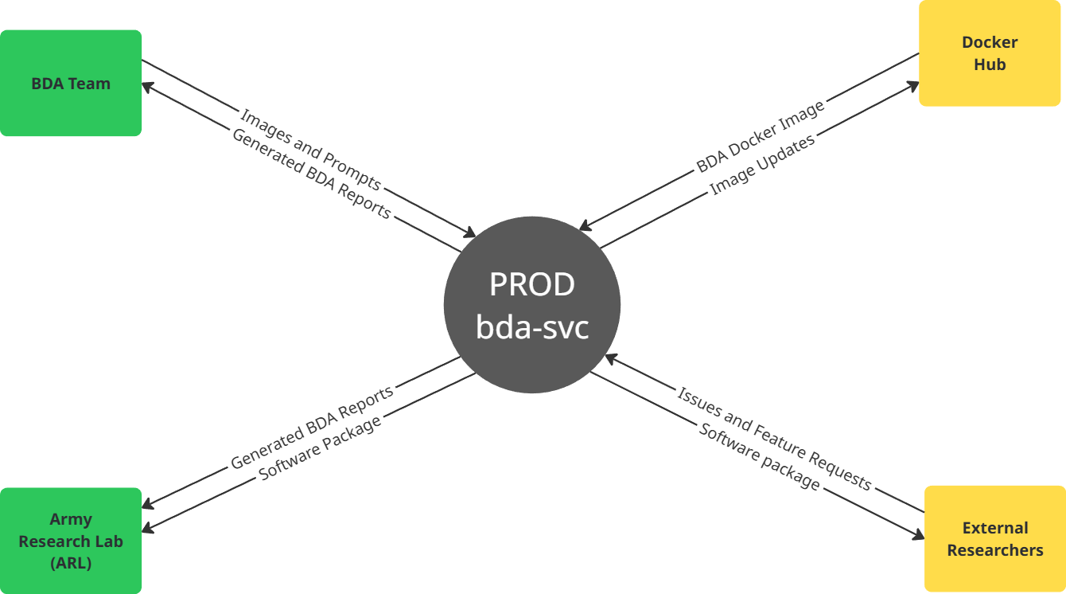

Figure A2, Development Environment

